**SFTP Documentation**

FTP client and scripts to upload the files to Oneserve FTP site with directory structure have been stored on TFS source control.

When deploying the SSIS Package which uses SFTP, SFTP folder needs to be copied to the C drive of the server.

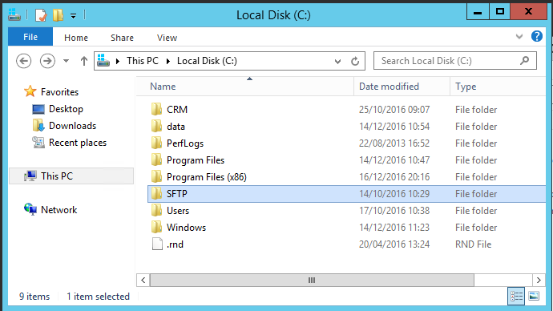

SFTP Folder contains 4 folders.

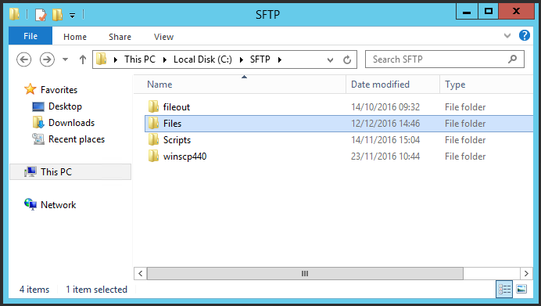

Fileout folder is empty. Files folder is used by the particular Package to store the generated xml file for SFTP to Oneserve.

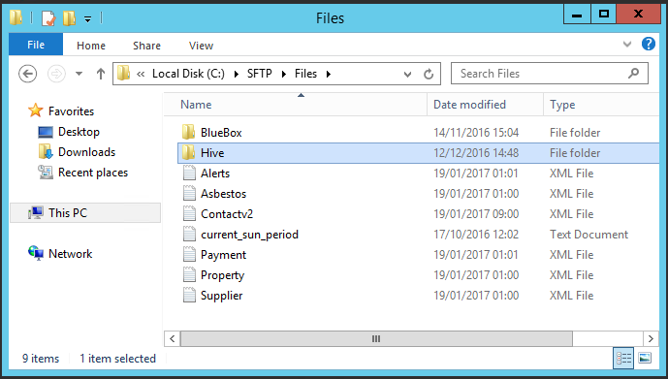

Scripts folder contains subfolders for all the scripts to upload the xml files to Oneserve SFTP server.

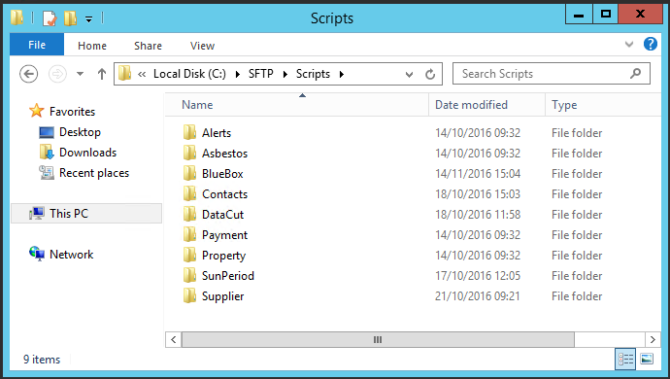

Below is the example of script in property folder which uploads the property.xml file Oneserve.

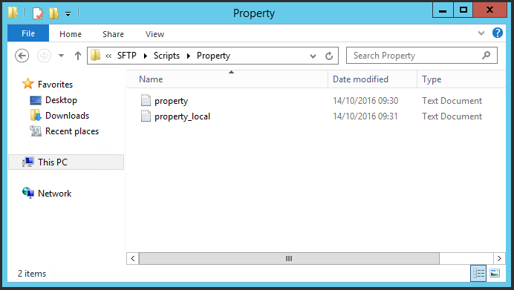

Property_local script is used to test the script for local ftp server. Property file is used for Oneserve.

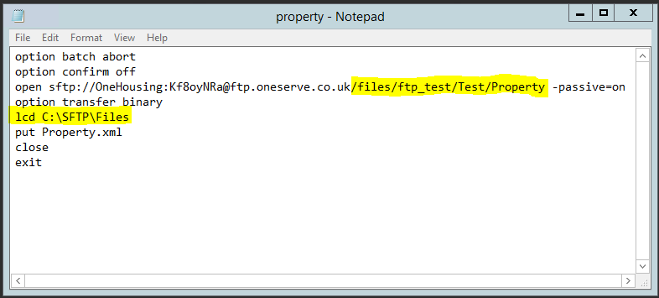

Folder structure needs to be amended when deployed to Production server with appropriate path.

Winscp440 folder contains FTP client and log files.

